

**Experiment No:8**

**Aim**: Implementation of any one Sorting Technique considering a real-world application

**Code:**

**QUICK SORT**

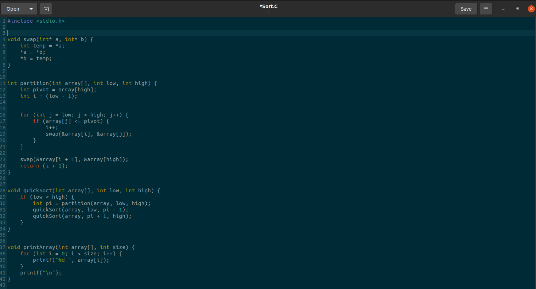

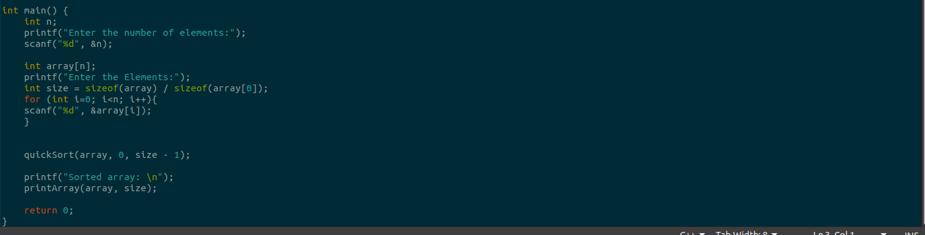

**Output:**

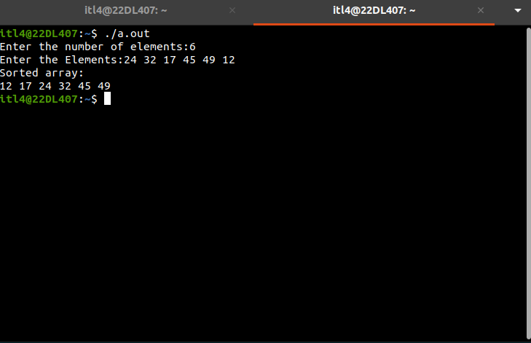

**Submitter Details -  
Name of Student: Yash.M.Dharamshi**

**Roll No.: 22  
Date of Performance: 27/09/2024**

**Date of Submission: 27/09/2024**